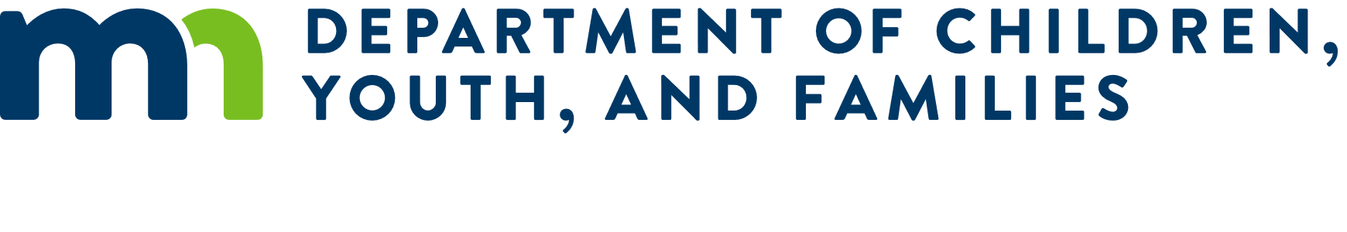

# Early Childhood Facilities Grant Program Questions and Answers

#### Question: Does the facility need to be government owned?

**Answer:** Yes, the facility must be owned by a state agency or political subdivision; however, the programs within the facility may be operated by a private and/or nonprofit entity under a use agreement with the state agency or political subdivision. (RFP clause 2.1 B)

#### Question: What counts as a political subdivision?

**Answer:** A political subdivision may be a county, city, town or school district.

#### Question: Are entities owned and governed by one or more political subdivisions eligible to apply for this grant as the lead applicant or should the applicant be one of the governing bodies?

**Answer:** Applicants must be a political subdivision of the state or state agency. The public entity must be the lead applicant and own the facility to be constructed or renovated. Collaboration with community partners is encouraged and should be demonstrated in the application.

#### Question: Our organization is planning a Early Childcare capital building in 2026, do we need to have an Early Childcare provider contracted or be a licensed contractor to apply for this grant?

**Answer:** No. A “use agreement” between the applying entity and early childhood program(s) is not required at the time of application. However, the renovated or newly constructed early childhood space(s) must be completed and fully operational by December 31, 2029. Plans on how to ensure grant agreement requirements will be met should be demonstrated in the application.

#### Question: How much funding is available or how much would be anticipated for each grantee award?

**Answer:** There is $900,000 available in total. An individual facility may be awarded up to $500,000 for each early childhood program housed in the facility, with a maximum of $900,000 for facilities housing three or more programs. (RFP clause 1.4)

#### Question: Once the project is constructed, what is the expectation of the facility and contracting with Early Childhood providers?

**Answer:** The renovated or newly constructed early childhood space(s) must be fully operational and serving children and families by December 31, 2029. However, a grant contract will not be executed by DCYF until a provider is in hand, and if applicable, a use agreement is executed and in place. Plans on how to ensure all grant agreement requirements are met should be included in the responder’s application. Per section 2.04 of the [Grant Agreement for Construction Grants](https://mn.gov/mmb-stat/debt-management/Capital%20Projects/Grant-Agreements/General%20Obligation/ProgramGeneralObligationBondsProgramGrantAgreemenConstructionGrant%202020.pdf), any resulting recipient(s) are required to provide annual evidence that bond funds are being utilized for the purposes specified and agreed upon in the grant agreement including the timeframe outlined in Section 2.11 Term of Grant Agreement.

#### Question: Do all match funds also need to be spent in the project window between August 2025 and December 2029?

**Answer:** Construction and renovation projects awarded with this grant must be completed and operational by December 31, 2029. Match funds as part of this grant should be spent by December 31, 2029.

Yes. All matching funds must be spent within the project window, ending no later than December 31, 2029. Since matching funds are dedicated to the proposed project, they must be fully expended by the project completion date. While proposals should show planning for these funds—even if they are not yet secured—a contract cannot be executed until Minnesota Management and Budget (MMB) verifies that the match is in place. Early verification helps ensure timely contract execution, full use of funds for construction or renovation, and that the early childhood program(s) will be operational by the end of 2029.

**Question:** Our organization has multiple early childhood services in the proposed facility, would each count as one “program” or would our organization overall count as one “program”?

**Answer:** Determining whether each early childhood service counts as a separate “program” depends on how the services are set up and delivered within the facility. More details about the organization’s structure would be needed to give an accurate response. Two scenarios are listed below to provide clarity – **these are only examples** – there are many other ways a facility might be structured (RFP clause 1.4).

**Example 1:** If a county-owned public building houses three or more early childhood programs at the facility requesting construction or renovation—such as Head Start in Rooms A & B, Early Childhood Family Education (ECFE) in Room C, and a licensed family child care provider in Room D—with appropriate Use Agreements in place, each is recognized as a separate program. Therefore, the county, as the lead applicant, is eligible to request the full $900,000 available through this RFP.

Conversely, if all four rooms are used for the same program, such as Head Start, it is considered a single program. In this case, the applicant is eligible to request up to $500,000 through this RFP.

**Example 2:** If a public school building, owned by the local school district, houses multiple early childhood programs at the facility requesting construction or renovation—such as Preschool in Rooms A & B, Early Childhood Family Education (ECFE) in Room C, and Early Childhood Special Education (ECSE) in Room D—each is considered a separate program. With these programs in place, the school district, as the lead applicant, is eligible to request the full $900,000 available through this RFP.

#### Question: If our application will be submitted by the county would they be the ones to complete the required forms and statements? Would we also need to sign the required statements and forms as well?

**Answer:** The state agency or political subdivision responding as the lead applicant will be responsible for completing and signing all required forms and statements outlined in Section 3.3 of the RFP guidelines, as the entity assuming all contractual and grant-related obligations.

Form 1 includes a section for the "Project Contact’s Name & Title," where a representative can be named as the primary point of contact for future project-related communications, if different than the applying individual.

#### Question: Does the scope of work include furniture procurement? If so, will furniture be required to be built in or will it be freestanding furniture?

**Answer:** Fixtures, furnishings (built in or freestanding), and equipment are bondable expenses when they **are both**: part of a new construction or major renovation, **and** a necessary part of the bondable project.