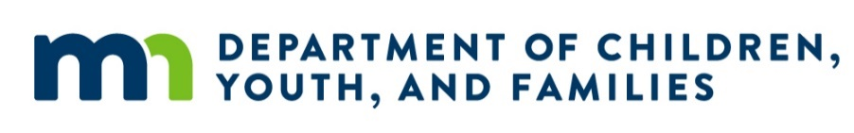
Pathway II Program Logo Here

Date
Dear <Parent Name>:
The State of Minnesota and <Pathway II program name> are happy to inform you that your <application/renewal> for an Early Learning Scholarship – Pathway II is approved. We look forward to helping your family access a high-quality education program to get your child ready for kindergarten.
<Child Name> has been awarded a scholarship to be used starting on <Award/Renewal date> through <End Date>. The scholarship may be up to <cap based on age, county, program type>. This funding supports your child in our program. The funding stays with our program to support other children if your child leaves. Read important details about your scholarship below.
If you have any questions, please feel free to contact us at <Pathway II program’s contact info>.
Sincerely,
<Pathway II program representative’s signature>
Things to know about your Early Learning Scholarship – Pathway II:
- Renewal: Scholarships are eligible to renew every year until your child becomes age-eligible for kindergarten. You will receive an email with instructions when it is time to renew. We will contact you by email and/or mail in April with instructions to renew.
- Aging Out: Your child is no longer eligible to use a scholarship once they become age-eligible for kindergarten. Children are age-eligible for kindergarten when they are five years old on September 1. The scholarship will expire on August 31 or the day before the child starts kindergarten, whichever date occurs first. Even if your 5-year-old does not start kindergarten on September 1, or you still have funds remaining, the scholarship will end on August 31.
- Absent Days: An absent day is any missed day that your child was scheduled to attend. The scholarship will cover a maximum of 25 absent days between July 1 and June 30 each year. Please be aware that you may be billed for absent days that exceed 25 in total between July 1 and June 30, unless an official exemption has been extended to your child(ren). Contact your Area Administrator to learn about exemption options.
- Scholarship Coverage: This scholarship may not cover the full cost of your child’s program. Depending on the cost of your child’s part-time or full-time schedule, you may need to pay part of the tuition. Scholarships will not pay you back for any payments you have already made to a program. Scholarships cannot be used for drop-in care.
- Payment to One Program: Scholarships will only pay one program at a time. If your child attends two programs (or more), you must choose one program for scholarship payments.
- Other Funding: This scholarship may be combined with other funding, such as the Child Care Assistance Program (CCAP). Payments from other funding sources will be applied first, and it is in your best interest to remain on any existing assistance program.
- Pathway I Scholarship: Your child has an Early Learning Scholarship – Pathway II, so you cannot accept a similar Early Learning Scholarship – Pathway I.
- Early Childhood Screening: Contact your local school district if your 3 to 5-year-old has not had this free screening done yet. Please provide us with the date and location of your child’s screening within 90 days of enrollment in your program. If you were previously enrolled in your program before being awarded a scholarship, inform us within 90 days of the start date of your scholarship.
- Siblings: Siblings of awarded children interested in a scholarship should submit a new application and new income documentation may be required. A scholarship cannot be transferred to a sibling or another child.

