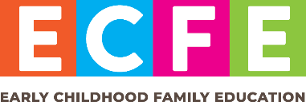

Raising kids is complicated, isn’t it? There  
are days when everything seems to go right, and…well, other days when nothing does. Having children is like that, but here’s the good news: **ECFE is here for you on all   
the days.**

Early Childhood Family Education (ECFE) is a statewide program in Minnesota that gives children and families the tools they need to thrive. Our classes and sessions are designed to help with the things that matter most:   
   
**1. Individual attention time** with parents or caregivers and their children to strengthen bonds

**2. Playful learning time** to help children with their next phase while minimizing separation anxiety

**3. Parenting discussion time** for parents and caregivers to talk about their parenting dreams, desires and concerns

**Being a part of ECFE is easy. We’re close to you, and our flexible sessions are built for busy families. Visit **(your website)** to learn how your family can thrive with ECFE classes. *Sample QR code. Please replace with your organization's QR code or delete.*