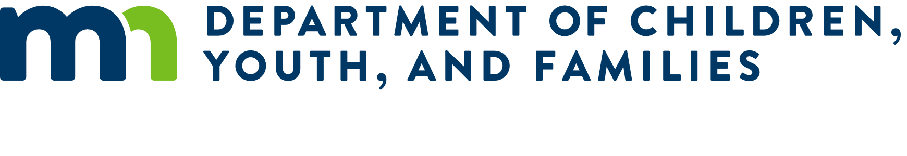

RFP Addendum No. 1 for to deliver Minnesota’s Indigenous Paths to Parenthood Curriculum

The State of Minnesota through the Minnesota Department of Children Youth, and Families, Child Support Division issues this addendum to the request for proposals identified above, which was issued on November 10, 2025

- Revision of Published Deliverables:

Revised to due date 1.2: “Proposals must be submitted on December 8 15, 2025, by 4:00pm Central Time.”
Revised responders’ questions 4.2: “Responders’ questions regarding this RFP must be submitted in writing on December 1, 2025 prior to 4:00 p.m. Central Time.”
Revised proposal submission 4.3: “The Proposal must be submitted electronically on December 8 15, 2025 prior to 4:00 p.m. Central Time , by 4:00 p.m. Central Time to be considered.”

- The numbering order of the RFP sections is revised as detailed below:

- The following deliverables are deleted and removed:

- Responses to Questions
“RFP Information Conference: December 2, 2025” (IPTP Info Session PPT.pdf) is attached and incorporated in this RFP Addendum as the Responses to Questions.

REMAINDER OF PAGE INTENTIONALLY LEFT BLANK

